Meeting: Improvement and Innovation Board
Date: 14 October 2022

Be a Councillor: KPI update

Purpose of report
For direction

Summary
The report provides an update for Improvement and Innovation Board on progress against the key performance indicators relating to the Be a Councillor campaign.
Is this report confidential?
No

Recommendation/s
Board Members are asked to comment on the report, provide feedback and make recommendations on future activity for the campaign.

Contact details
Contact officer: Helen Jenkins
Position: Head of Leadership
Phone no: 07464 652732
Email: helen.jenkins@local.gov.uk

Be a Councillor: KPI update

Background
- The LGA’s Highlighting Leadership offer forms part of our wider package of sector-support. We offer a range of programmes, events and resources aimed at supporting and developing councillors and local government officers at all levels. This report focusses on one key part of the deliverables: the Be a Councillor campaign.
- The campaign has two strands: the LGA’s political group office run their own successful campaigns. There is also a national campaign which is focussed on generally raising the profile of the role of councillor, encouraging more people to find out about the role and finding out the route to take if they want to become a councillor. This is achieved through information sharing via the Be a Councillor website and creating tools and resources for councils to run their own local campaigns. The content of this report is predominantly focussed on the national campaign.
- The Be a Councillor campaign has two specific Key Performance Indicators (KPIs) in the current Grant Determination Letter with Department for Levelling Up, Housing & Communities (DLUHC):
- Be a Councillor Campaign to attract interest from at least 500 non-councillors, including through enquiries and attendance at events – by end of December 2022.
- Long term campaign launched to attract disabled candidates to stand for council elections – by end of September 2022.
- Progress against these KPIs is outlined in this report.

Enhanced Be a Councillor campaign
- The Leadership Team is working to deliver an expanded Be a Councillor Campaign with refreshed approaches to awareness raising about the role of councillor. The campaign aims to ensure better representation in local government of the communities it serves, with the diversification of skills, experience and knowledge from new talent attracted to the role. We are on target to meet our KPI to track interest from at least 500 non-councillors by the end of December 2022. As Be a Councillor often uses ‘broadcast’ techniques to raise awareness there are challenges with tracking engagement and therefore in reality it is likely that many more people have seen and engaged with the campaign than those we have had direct contact with.

- At the end of Quarter 2, the campaign had attracted over 489 non-councillors’ through events run by the LGA Political Group Offices and the Leadership Team, and through enquiries by email and social media. Further events are planned with partners on Thursday 24 and Saturday 26 November 2022. Our new Be a Councillor newsletter was launched recently, gaining over 60 sign ups in the first day. People can sign up via a button on the website to receive information throughout the year about being a councillor, how to get involved and to register for events.

- Further and more detailed information about the work undertaken to achieve the KPI is set out below.

- In October 2021, the Leadership team updated the Improvement and Innovation Board on focus group research undertaken by The Young Foundation which captured the views and experiences of under-represented groups to help refresh the Be a Councillor campaign.

- Since then, progress has been made through the following work:
  - Engaged with expert under-represented group organisations: Elect Her, My Life My Say, Operation Black Vote and Shout Out UK.
These partnerships will focus on events, social media communications and resources to help us reach key target audiences. An event with Shout Out UK was held in June 2022 and the partnership was officially launched on social media on International Youth Day.

  - The ‘Awareness to Action’ and ‘from passive support to do-er’ models from the Young Foundation Research have been built into the campaign: For example, through refreshed social media posts to help raise awareness of the role; and partnering with the organisations for more intensive activities to support people to take action and stand for election.

Awareness to Action model | Passive supporter to Do-er model
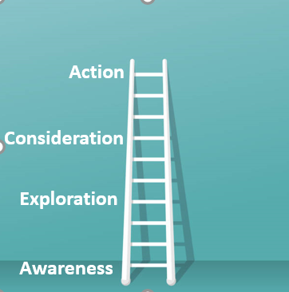 | 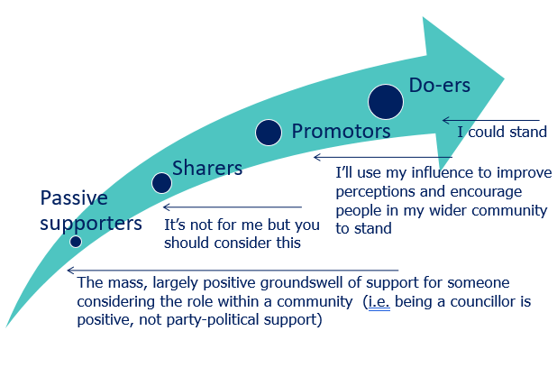

  - New website content with additional detail asked for by the focus groups. For example, more detail about the day-to-day role, and on the practical considerations of being a councillor such as remuneration and time commitment.

  - Refreshed social media messaging and new photography with councillors across the country (and more photoshoots to take place later this year). The photography has a new look, focussing on councillors in action in their community to help raise greater awareness of what the role entails in practice.

  - Embedding a stronger outreach and targeted marketing approach to the campaign – by carrying out stakeholder mapping to link up with organisations which share our aims, and commissioning events with our partners to reach out to target networks.
  - New case study template and case studies to provide a stronger focus on the day-to-day role and the specific impacts and achievements councillors have made, with some new case studies on the Be a Councillor website and more to follow.
  - Signposting more clearly to Debate not Hate and Civility in Public Life on the Be a Councillor website, and also as discussion points in events with partners.

- Crucially the elements detailed above also form the basis of new toolkit resources for councils to run their own local Be a Councillor campaigns, in the spirit of sector led improvement – for example supporting councils’ outreach to under-represented groups with stock social media posts and photography that councils can use on their own platforms, as well as email templates to make initial contact with and engage local partner organisations.
Support for Disabled Councillors and Candidates
- In January 2022, the Leadership team received additional funding from (DLUHC) to deliver a package of support for disabled councillors and candidates which was extended into the grant agreement for 2022/23.
- This support offer is designed to increase the representation of disabled people in local politics and accelerate their development to become leaders in local government. It covers the whole life cycle of a councillor: from taking the first step to go for election, to developing your leadership skills as an experienced councillor.
- The main KPI objective from Government that relates to the Be a Councillor campaign is:
- To launch a long-term campaign to attract disabled people to stand for council elections (by the end of September 2022)
Additionally, the Leadership team is delivering on the following disability-focused KPI objectives:
- To deliver a coaching programme which gives support to at least 20 disabled councillors, with at least 85% of participants indicating the coaching has had a positive impact on their development (by the end of March 2023)
- To deliver a bespoke leadership development programme for disabled councillors, which provides councillors with unique networking opportunities and support.
- To implement recommendations to improve the accessibility of the NGDP in time for the 2022/23 programme.
- The LGA’s most recent councillor census found that disabled people are consistently underrepresented on councils. In 2022, 15.5 per cent of councillors declared a disability or long-term impairment. This compares to just over 20 per cent of the general population having a limiting long-term illness, condition or impairment.
- A national campaign is now underway to attract more disabled people to consider becoming a councillor. This campaign has been co-produced with disabled people and councillors and led by community engagement specialists Vocal Communities. In line with the extensive user testing and research carried out, the campaign will provide focused and targeted support for disabled people whilst integrating into the main Be a Councillor campaign. This is also consistent with the recommendations of the Young Foundation research from 2022.
- We are taking a holistic approach to inspire a new generation of disabled councillors, but also recognise that there are practical considerations. Our new guide, Improving Access to Local Government Elected Office for Disabled People, has marked the launch of the campaign.
- This guide aims to break down what it means to be a councillor and offers specific advice and support for disabled people who are considering the role. It has been shaped with the involvement of currently elected disabled councillors, who have also contributed to the campaign’s photography and case studies. The guide is accompanied by practical support for councils, which aims to improve awareness, accessibility, and inclusion at every stage of becoming a councillor.
Examples from the campaign
Image 1: Councillor Steve Darling (Leader of Torbay Council, Liberal Democrat) and Councillor Mandy Darling (Mayor of Torbay, Liberal Democrat) featuring on the front cover of the Be a Councillor guide for disabled people.
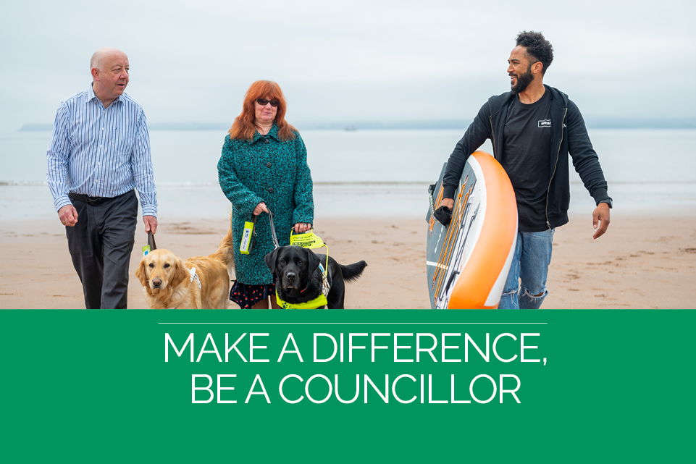
Image 2: Councillor Lana Hempsall (Broadland and South Norfolk Council, Conservative) featuring on the LGA twitter account (@LGAcomms).
Image 3: Councillor James Rathbone (Lewisham Council, Labour) featuring on an editable poster for councils from the Be a Councillor toolkit for council campaigns.
Image 4: Councillor David Beaman (Waverley Borough Council, Independent) sharing his journey as a councillor in a case study on the Be a Councillor website.
- Next steps for Be a Councillor:
- Deliver an expanded national Be a Councillor campaign, in collaboration with Political Group Offices; our partners Elect Her, My Life My Say, Operation Black Vote and Shout Out UK; new disability expert organisations; and by supporting councils with our refreshed toolkit.
- Deliver a series of Be a Councillor online and in-person events with partners for under-represented groups.
- Produce bespoke resources and materials for under-represented groups, with the support of our campaign partners.
- Provide enhanced social media and press promotion to raise greater awareness of the role and the support available (e.g. new website content and guide for disabled people) as well as focussing on key dates such as Black History Month, Disability History Month and International Day of Disabled Persons.
- Provide support to councils to deliver local Be a Councillor campaigns and activities and promote the new Be a Councillor toolkit with all councils in England.
- Establish the new Be a Councillor newsletter to respond to frequently asked questions and emerging topics and to encourage and support people to stand for election.
- Championing role models by engaging a diverse range of councillors in producing case studies, taking part in photoshoots, and writing promotional material for our resources and campaigns; including raising the profile of disabled leaders in local government.
- Recommendations are currently being finalised from a research project that focusses on the barriers facing younger people when standing for election. Outcomes of the project will include the creation of resources specifically aimed at making the role of councillor more accessible to younger people. This will include guidance for employers, practical information about the logistics of the first few months of being a councillor and resources to support earlier education about the role of the councillor.
Proposal
- Board Members are asked to comment on the report, provide feedback and make recommendations on future activity for the campaign.

Implications for Wales
- There are no direct implications for Wales as the Be a Councillor campaign is funded by the Improvement Grant for English Councils. However, the team periodically share practice with the WLGA, who run their own Be a Councillor campaign.

Financial Implications
- All actions will be accomplished within the agreed budget for Be a Councillor.

Equalities implications
- The Be a Councillor campaign is aimed at increasing the pool of people that stand for election, so that councils are representative of their communities.
- As part of the LGA’s Support for Disabled Candidates and Councillors, a targeted and bespoke campaign is being delivered to support disabled people to become councillors. This forms part of the Be a Councillor campaign and aims to increase the representation of disabled people in local government.

Next steps
- The Be a Councillor team will take on board comments and recommendations by the Board.

